11. Perform a 180-degree rotation clockwise along the y-axis for the given image
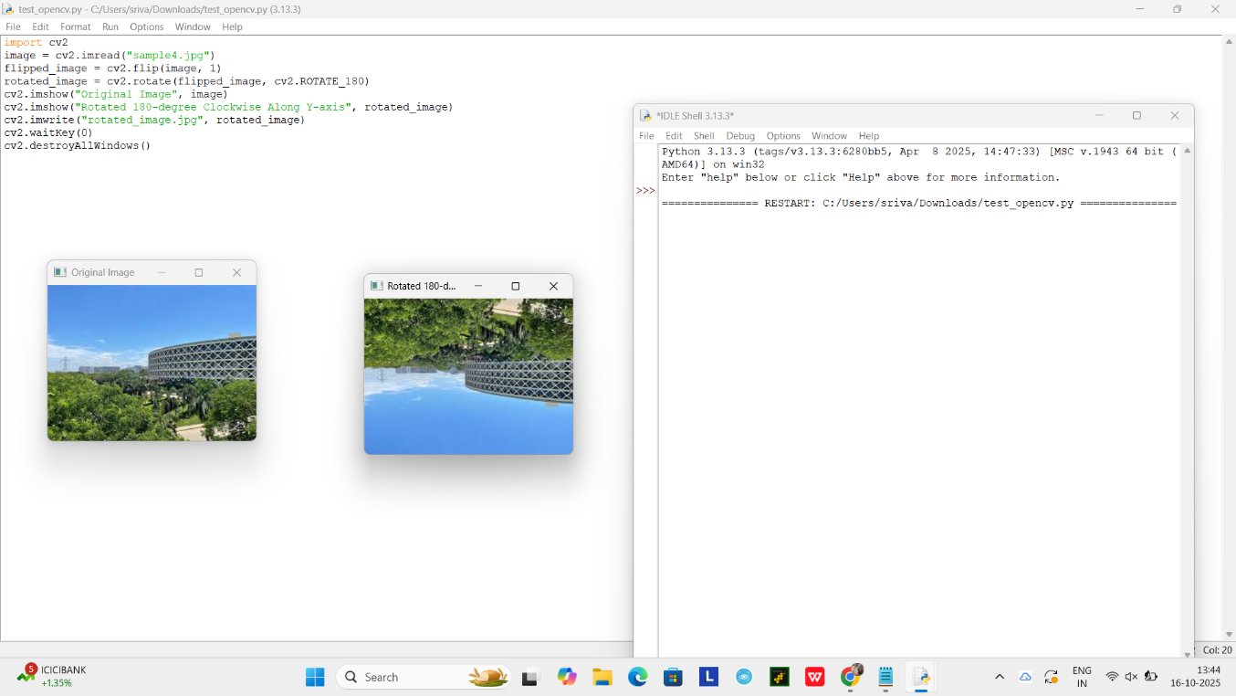

12. Perform a 270-degree rotation clockwise along the y-axis for the given image.
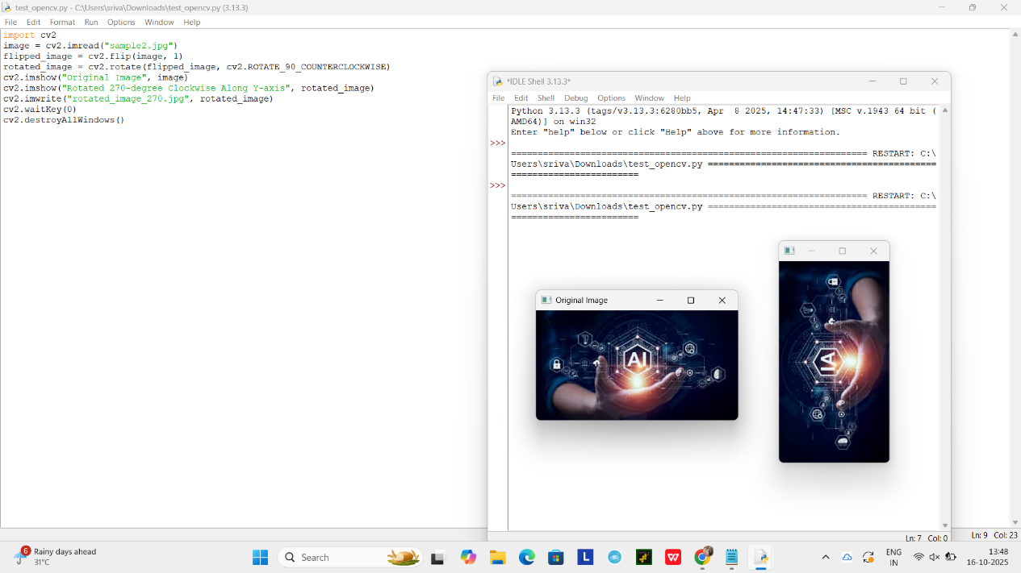

13. Perform Affine Transformation on the given image using python and Open CV.
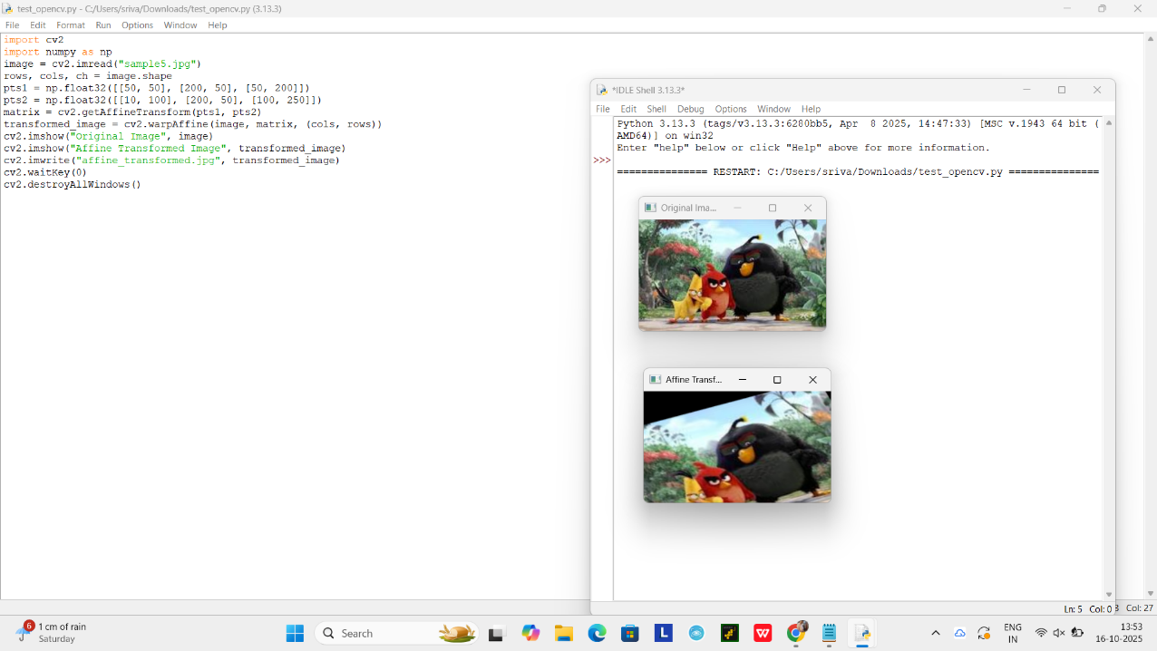

14. Perform Perspective Transformation on the given image using python and Open CV
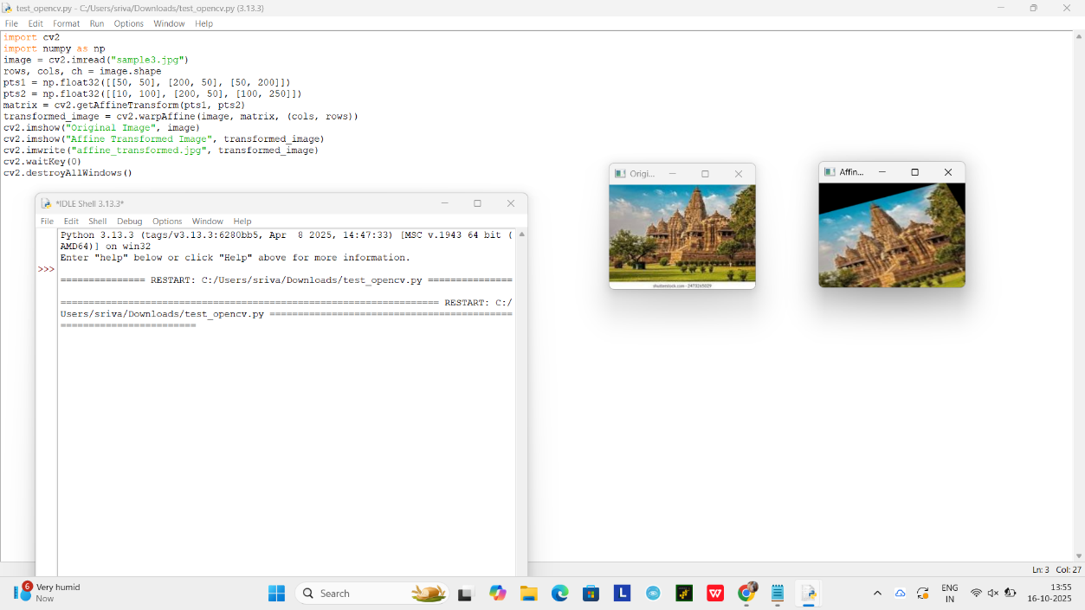

15. Perform basic Image Handling and processing operations on the image is to read an image in python and detect the corners in the image using Harris Corner Detection function

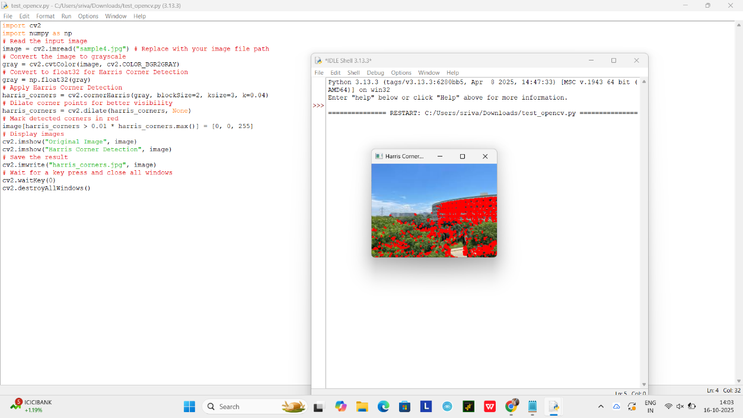

16. Implement a Sobel algorithm using Open CV to filter the input image.

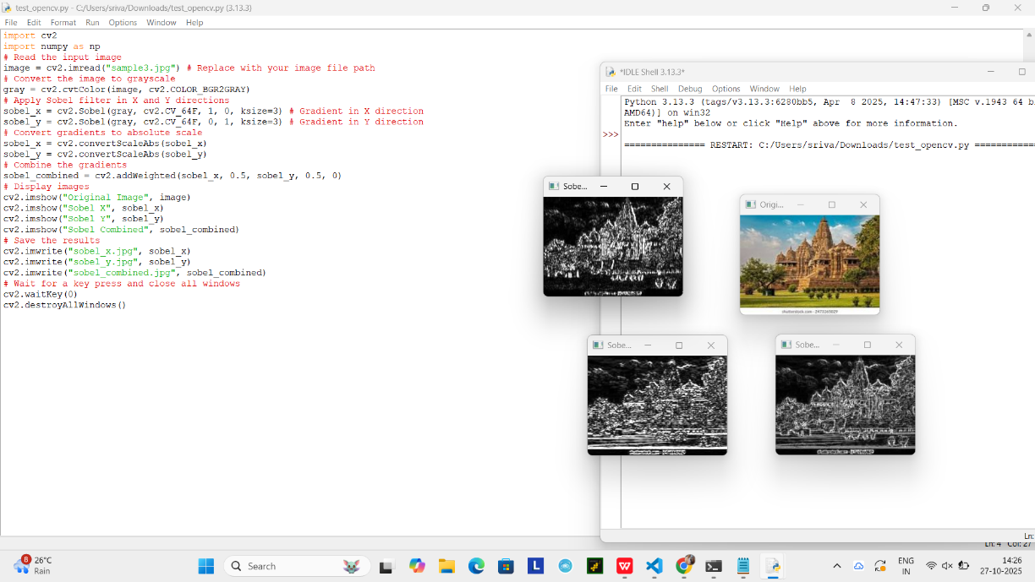

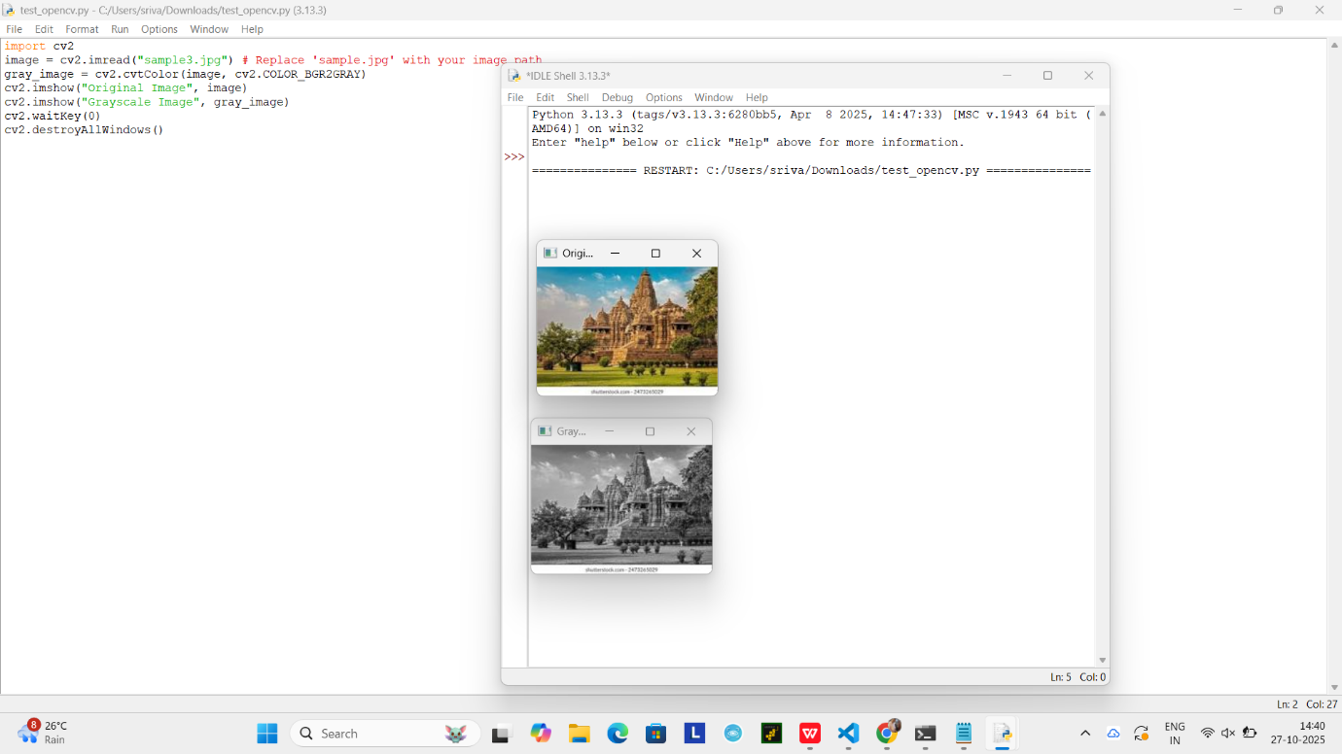
17. Design and implement a water marking technique to insert the watermark into the original effectively image using Open CV.

18 Implement image cropping, copying and pasting to select a region of interest (ROI) from the source image using Open CV.

19 Implement the Erosion Morphological operations technique using Open CV in python.

20 Implement the Dilation technique as a Morphological operation to dilate the foreground regions based on Open CV.

